Author SissyMarySue (Wendy Muhlhauser) five programs through 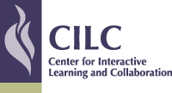
PROGRAMS BASED ON AWARD WINNING (Globally Mindful, Mom’s Choice Awarded) & FIVE STAR Books:
Jelly Beans the Cheetah and Hope
EMPATHY AIRLINES: Jelly Beans the Cheetah and Hope, Book 2
(Black female pilot & Asian male co-pilot)
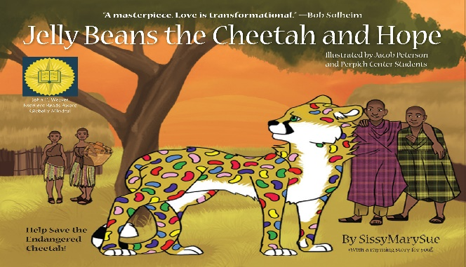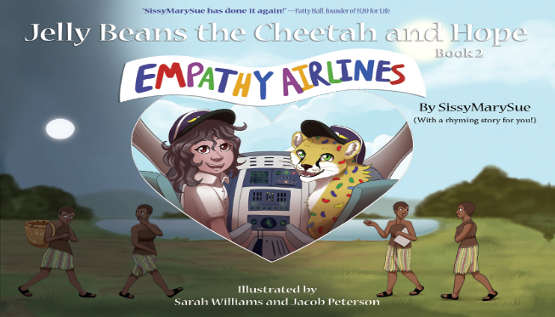
PROGRAMS:
1) EMPATHY - Jelly Beans the Cheetah and Hope
2) EMPATHY AIRLINES- Girls and Boys Can Be Pilots!
3) Cheetah FACTS
4) Clean Water- is Essential to Live!
5) Bullying vs. Connection
All youth should be represented in the books they read, in media and technology. They deserve to be fully represented and empowered. I focus on literacy, language development, reading readiness, social-emotional growth (especially EMPATHY & UNITY), critical thinking and global themes.
Find Books, Audio Books & Album:
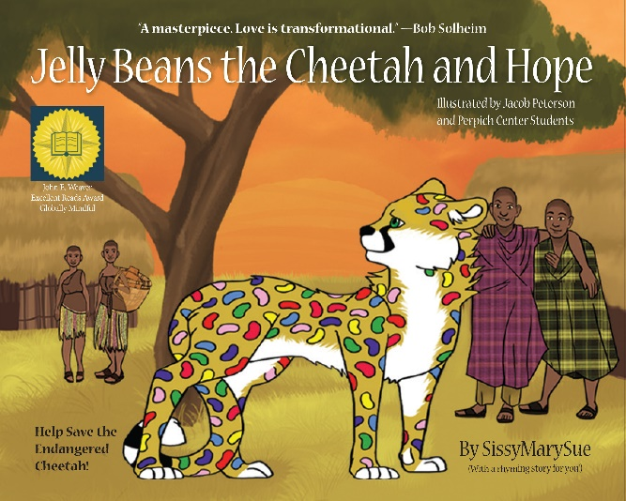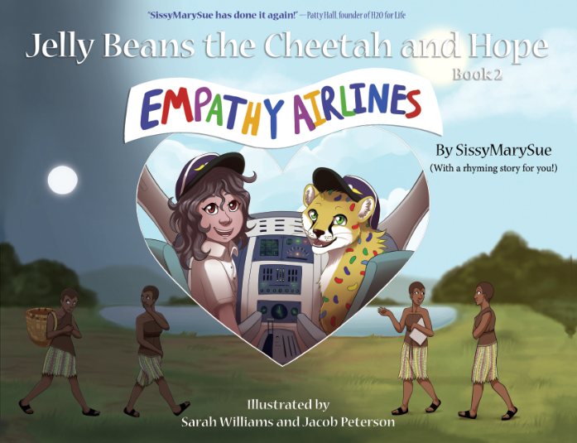
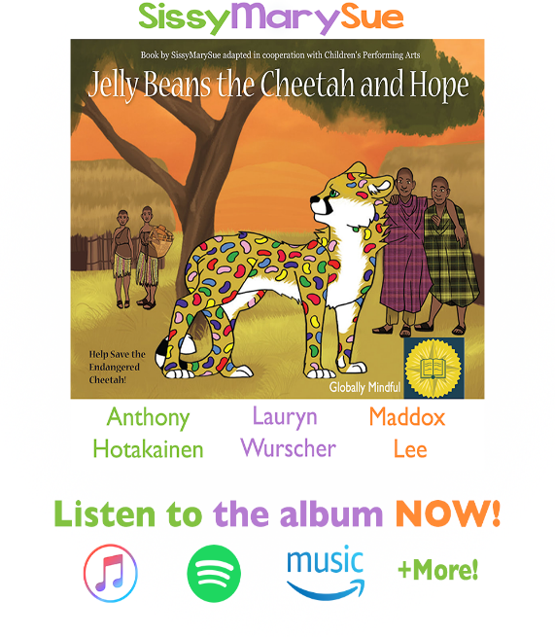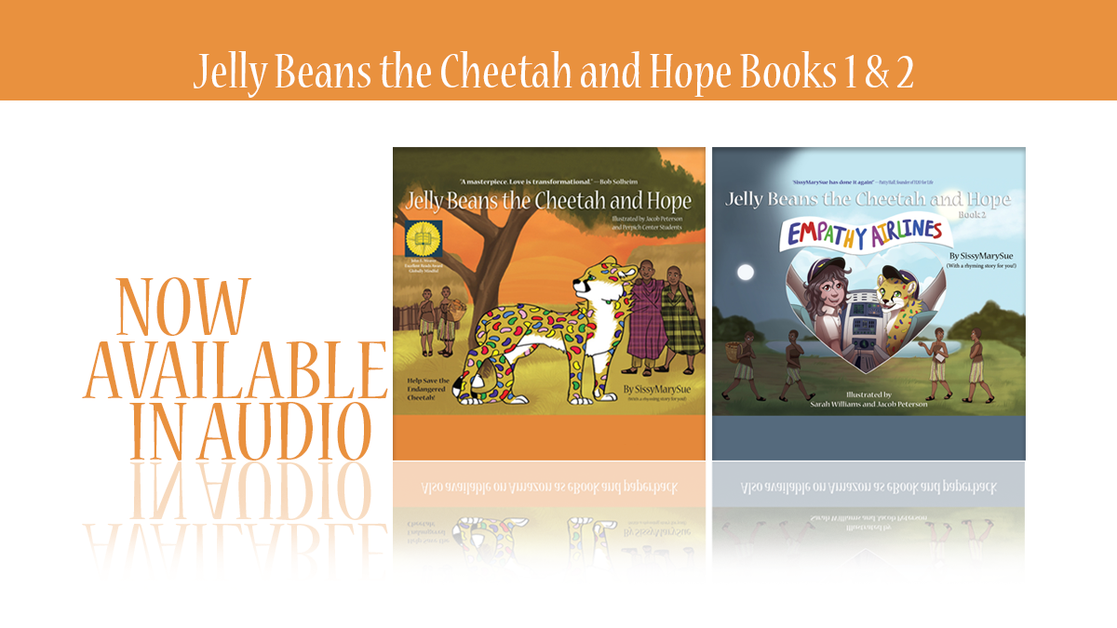
BUY or ORDER BOOKS:
Barnes & Noble, Amazon, Target
Ten Thousand Villages, Red Balloon, BOULDER BOOKSTORE
Walmart, Itunes, Spofify, iheart Radio
Go to shop Page on www.sissymarysue.org and click on a logo 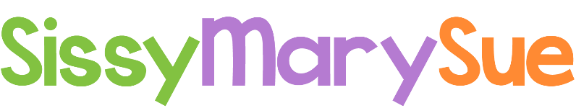.ORG

